**THE UNITED REPUBLIC OF TANZANIA**

**DODOMA CITY COUNCIL**



**LAND TENURE IMPROVEMENT PROJECT (LTIP)**

**ENVIRONMENTAL AND SOCIAL MANAGEMENT PLAN FOR URBAN CERTIFICATION PROCESS IN DODOMA CITY COUNCIL**



**Prepared by:**

**THE DODOMA CITY COUNCIL**

**1 CDA STREET, 40477**

**P.O. BOX 1249, DODOMA, TANZANIA**

**TEL: +255 (22) 26 23 24 817**

**E-MAIL:** [**CD@DODOMACC.GO.TZ**](mailto:CD@DODOMACC.GO.TZ)

**April 2024**

# ACKNOWLEDGEMENTS

The Environmental and Social Management Team (ESMT) team for Dodoma City Council implementing the Land Tenure Improvement Project (LTIP) is indebted to all those who were met and devoted their time to have discussions or meetings with the the team and support the development of this Environmental and Social Management Plan (ESMP) document. The team is also thanksful to the Environmental and Social Management Team of the project at the Ministry of Lands, Housing and Human Settlement Development (MLHHSD) for their guidance during preparation of this ESMP. Dodoma City Council ESMT wishes to extend their gratitude to the World Bank Consultants for their technical support, quality assurance and proof reading of the ESMP to ensure that it meets the country and the WB Environmental and Social Framework (ESF). Since the number is quite big it will be dificult to mentioned all of them. We sincerely dedicate our appreciation to all of them and say thank you very much.

# ESMP PREPARATION TEAM

# 

|  |  |  |  |
| --- | --- | --- | --- |
|  | NAME | PROFFESION/POSITION | ORGANIZATION |
| 1 | Ally Shedehwa Mfinanga | District Environmental Officer | Dodoma City Council |
| 2 | Hidaya Abdala Mzengi | Community Development Officer | Dodoma City Council |
| 3 | Alpha Mangula | Environmental and Social Management Coordinator, Land Tenure Improvement Project (LTIP) | Ministry of Lands, Housing and Human Settlement Development (MLHHSD) |
| 4 | Tumaini Setumbi | Social Development Officer, Land Tenure Improvement Project (LTIP) | Ministry of Lands, Housing and Human Settlement Development (MLHHSD) |
| 5 | Regina Kabwogi | Environmental Specialist, Land Tenure Improvement Project (LTIP) | Ministry of Lands, Housing and Human Settlement Development (MLHHSD) |
| 6 | Robert Kishiki | Social Development Specialist, Land Tenure Improvement Project (LTIP) | Ministry of Lands, Housing and Human Settlement Development (MLHHSD) |

TABLE OF CONTENT

ACKNOWLEDGEMENTS 2

ESMP PREPARATION TEAM 3

LIST OF TABLES 6

LIST OF FIGURES 6

LIST OF ABBREVIATIONS AND ACRONYMS 7

CHAPTER ONE 8

INTRODUCTION 8

1.1 Background Information 8

1.2 LTIP Project Scope in Dodoma City 8

1.2.1 General Objectives of ESMP 8

1.2.2 Methodology for Preparation of ESMP 9

CHAPTER TWO 9

BASELINE ENVIRONMENTAL AND SOCIAL CONDITION OF THE PROJECT AREA 9

2.1 Introduction 10

2.1.1 Mapinduzi 10

2.1.2 Mkwawa 11

2.1.3 11

Bihawana 11

2.2 Common Social Issues in Mapinduzi, Mpunguzi and Mbabala Mitaas 12

CHAPTER THREE 14

LEGAL AND INSTITUTIONAL FRAMEWORK 14

3.1 Introduction 14

3.2 Country’s Legal Framework 14

3.3 World Bank Environmental and Social Framework 15

CHAPTER FOUR 17

ENVIRONMENTAL AND SOCIAL IMPACTS, RISKS AND MITIGATION MEASURES 17

4.1 Introduction 17

4.2 Project Social Benefits 17

4.3 Negative Social Risks and Impacts 17

4.4 Project Positive Environmental Impacts of Land Certification 18

4.5 Negative Environmental Impacts of Land Certification 18

4.6 19

Mitigation Measures of the Identified Impact 19

CHAPTER FIVE 24

ENVIRONMENTAL AND SOCIAL MONITORING PLAN (ESMP) 24

5.1 Introduction 24

CHAPTER SIX 28

INSTITUTIONAL ARRANGEMENTS FOR IMPLEMENTATION OF ESMP IN DODOMA CITY 28

6.1 Introduction 28

The implementation of ESMP will follow the plan stipulated in ESMP. For Dodoma City Council the following will be involved in the implementation of this ESMP. 28

6.2 ESMP Implementing Institutions 28

6.3 Supervision and Monitoring Roles 28

6.4 Capacity Development and Training 29

CHAPTER SEVEN 30

CONCLUSIONS AND RECOMMENDATIONS 30

7.1 Conclusions 30

7.2 Recommendations 30

# LIST OF TABLES

**Table 1: Mitigation Measures of Identified Impacts** 20

**Table 2: Environmental and Social Monitoring Plan for Implementation of Mitigation Measures during Land Certification and Registration Process in Dodoma City Council** 25

**Table 3: Training Activities** 29

# LIST OF FIGURES

Figure 1: Features in Mapinduzi Project Area 11

Figure 2: Features in Mapinduzi Project Area 11

Figure 3: Features in Bihawana Community 12

# LIST OF ABBREVIATIONS AND ACRONYMS

|  |  |  |
| --- | --- | --- |
|  |  |  |
| CBO | - | Community Based Organization |
| CCRO | - | Certificate of Customary Right of Occupancy |
| CoC | - | Code of Conduct |
| CRO |  | Certificate of Right of Occupancy |
| DED |  | District Executive Director |
| DEMO | - | District Environmental Management Officer |
| E&S | - | Environmental and Social |
| EA | - | Environmental Assessment |
| EIA | - | Environmental Impact Assessment |
| EMA | - | Environmental Management Act 2004 |
| EMO | - | Environmental Management Officer |
| ES | - | Environmental Screening |
| ESCP | - | Environmental and Social Commitment Plan |
| ESMT | - | Environmental and Social Management Team |
| ESMF | - | Environmental and Social Management Framework |
| ESMP | - | Environmental and Social Management Plan |
| ESF |  | Environmental and Social Framework |
| ESS | - | Environmental and Social Standard |
| GBV | - | Gender Based Violence |
| GoT | - | Government of Tanzania |
| GRM | - | Grievance Redress Mechanism |
| HIV/AIDS | - | Human Immunodeficiency Virus/Acquired Immuno- Deficiency Syndrome |
| ILMIS | - | Integrated Land Management Information System |
| LGAs | - | Local Government Authorities |
| LTIP | - | Land Tenure Improvement Project |
| MLHHSD | - | Ministry of Land, Housing and Human Settlement Development |
| NEMC | - | National Environment Management Council |
| NGO | - | Non-Governmental Organisation |
| OHS | - | Occupational Health and Safety |
| PLUM | - | Participatory Land Use Management |
| PO-RALG | - | President’s Office Regional Administration and Local Government |
| RPF | - | Resettlement Policy Framework |
| SEA | - | Sexual Exploitation and Abuse |
| SEP |  | Stakeholder Engagement Plan |
| TOR | - | Terms of Reference |
| URT | - | United Republic of Tanzania |
| VLUM | - | Village Land Use Management (Committee) |
| VLUP | - | Village Land Use Plan |
| VG | - | Vulnerable Groups |
| VGPF | - | Vulnerable Groups Planning Framework |
| WB | - | World Bank |
| WEO | - | Ward Executive Officer |

# CHAPTER ONE

# INTRODUCTION

## 1.1 Background Information

The Government of Tanzania (GoT) through the Ministry for Lands, Housing and Human Settlements Development (MLHHSD) is implementing Land Tenure Improvement Project (LTIP). The Project aims at increasing security of land rights and efficiency in land administration. It promotes land-based investments and ensures inclusion for social economic development in both urban and rural areas. The key project results indicators would be: number of Certificates of Rights of Occupancy (CROs), Certificates of Customary Rights of Occupancy (CCROs) and Residential Licenses issued and registered (gender disaggregated); increased number of land and property transactions; reduced number of land conflicts; increased tenure security, and gender disaggregated (survey data).

## 1.2 LTIP Project Scope in Dodoma City

The Dodoma City is one of beneficiaries of LTIP activities. In Dodoma City, the project involves regularization activities involving issuance of CROs; renovation of one building to be used for storage and processing CROs; and construction of Regional Land Office and Archive building.

This ESMP is specifically for regularization activities. The ESMPs for buildings will be developed after completion of specific project Environmental and Social Impact Assessment (ESIA). In total three Mitaas namely Mkwawa, Mapinduzi and Mbabala located in Mbabala, Ngho’ngona and Mpunguzi wards respectively will be provided with CROs. The project is expected to issue over 30,000 CROs in the three Mitaas (estimation of 10,000 CRO from each mtaa).

Regularization process in Dodoma shall adapt Hybrid Contemporary Approach as described in the CRO Manual Chapter 5. The process involves the following key activities:

1. Community sensitization about the project
2. Ascertaining environmental and social baseline condition of the project area;
3. Conducting screening which aims at determining environmental and social risk levels with subsequent devising mitigation measures to be adopted during adjudication and planning;
4. To identify linear network structures so as to harmonize road linkages;
5. To prepare scheme of regulations and scheme of surveys plan;
6. Approval of the plans which is done at regional land office; and
7. Issuance of CROs.

The aforementioned activities have potential to cause environmental and social (E&S) risks and impacts. To address the potential E&S risks and impacts, this ESMP has been prepared to guide LTIP activities and all implementers.

### 1.2.1 General Objectives of ESMP

This ESMP is important tool for managing and monitoring of the E&S impacts associated with the proposed project activities. Specifically, it depicts how the organizational capacity and resources will be utilized to implement the mitigation measures proposed. Therefore, the Government Project implementation team as well as Private Firms will implement the project in accordance to this ESMP.

Specifically, this ESMP is designed to attain the following objectives:

1. Identification of potential E&S impacts associated with urban certification;
2. To develop mitigation/enhancement measures to minimize E&S risks and impacts;
3. To define implementation arrangement and organization structure of ESMP;
4. To identify the parameters to be monitored and the respective tools that are used in monitoring and reporting.

### 1.2.2 Methodology for Preparation of ESMP

This ESMP is consistent with the Project’s Environmental and Social Management Framework (ESMF) and it was prepared through undertaking the following activities:

1. Undertaking environmental and social screening to determine risks and impacts associated with certification process which was conducted through using:
2. Annex 4 of ESMF on: Screening Checklists for environmental and social issues.
3. Annex 6 of ESMF: Environmental and Social Safeguards Criteria for selecting project specific areas; and
4. Annex 5 of ESMF: Terms of Reference for the preparation of ESMP.
5. Undertaking literature review which was central in ascertaining environmental and social baseline condition of the project area.
6. Identification of mitigation, enhancement, and monitoring measures for the identified impacts.
7. Validation of mitigation, enhancement, and monitoring measures through stakeholders’ engagement; and
8. Finalization of ESMP report and sharing with wider stakeholders.

# CHAPTER TWO

# BASELINE ENVIRONMENTAL AND SOCIAL CONDITION OF THE PROJECT AREA

## 2.1 Introduction

The topography of Dodoma City is characterized by upland plateau with an altitude ranging between 900 – 1000m above sea level with beautiful stony hills such as Imagi, Isanga, Mkalama and Mlimwa. These hills are also known as inselbergs. In Dodoma city there are several gullies, valleys and flat areas that require intention when undertaking planning and regularization activities. Although Dodoma City have no permanent rivers, gullies and seasonal streams exist and collect storm water during rainy seasons; thus, LTIP will need to make attention to them.

In Dodoma City Council, three Mitaas of Mkwawa, Mapinduzi and Mbabala located in Mbabala, Ngho’ngona and Mpunguzi wards respectively have been currently selected for Urban Certification. The selected Mitaa are among the areas where land transactions are taking place frequently in Dodoma city. These areas are peri-urban with low housing density which allow access to houses through informal road hierarchy. The prevailing environmental and social conditions in each Mtaa is detailed below:

### 2.1.1 Mapinduzi

Mapinduzi Mtaa is found in Ng’hong’ona ward, located Southern East of Dodoma City about 40km from the Central Business District (CBD), next to Dodoma University. The Mtaa is characterized by seasonal streams which flows from North to South of the city and gullies which are susceptible to soil erosion and floods (**Figure 1**). Presence of these features affect ownership of land who reside within 60m as per the Environmental Management Act of 2004.

Agriculture is the major economic activity conducted by large section of population at Mapinduzi which necessitates the need for the project to acknowledge mixed land uses in urban areas. Within the project area, there is a section of the community residing along the Dodoma –Kikombo road reserve which will be identified by the project and be compensated by TANROADS as per the National Road Act No. 13 of 2007.

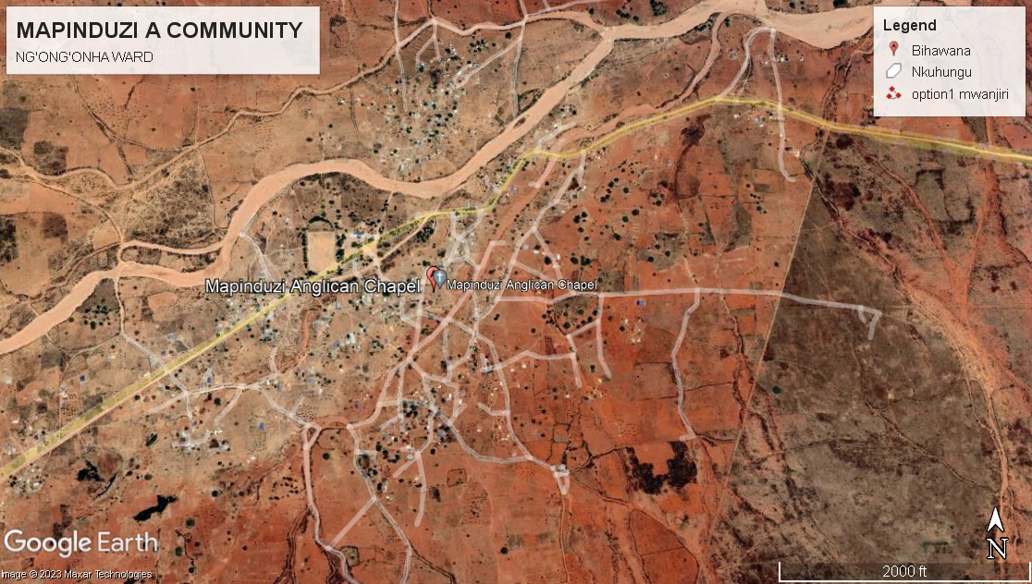

#### Figure 1: Features in Mapinduzi Project Area

### 2.1.2 Mkwawa

Mkwawa Mtaa is in Mpunguzi ward along the Iringa-Dodoma Road. Mpunguzi area is characterized by large grape farms and scattered settlements with mixed land use, which include: residential, urban farms, institutions, open spaces for public use and public facilities. There is seasonal stream which flows from South to North of Dodoma City (**Figure 2**). This river is steadily increasing in width due to river bank erosion. In Mapinduzi area, for instance, the presence of these features has extended the buffer zone affecting boundaries of neighboring land. Shifting of boundaries or the highest water mark affects legal ownership of land for people who reside within 60m from the highest water mark as per the Environmental Management Act of 2004, The study in project area which goes together with community discussions and meetings shows that in every year a portion of river bank is eroded and as a result land parcels along the stream keep on degrading due to soil erosion.

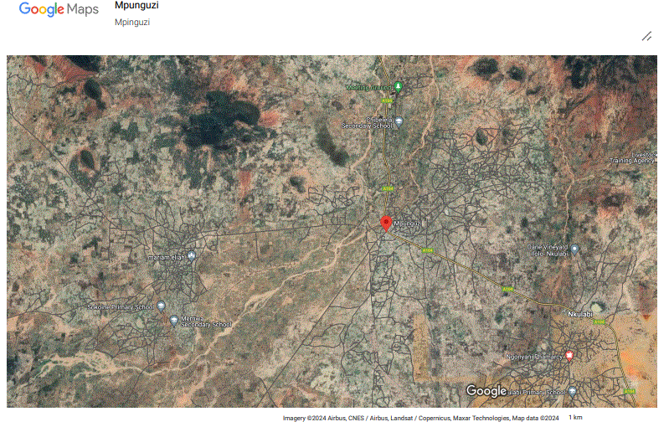

#### Figure 2: Features in Mapinduzi Project Area

### 2.1.3 Bihawana

The Bihawana Mtaa is in Mbabala ward, and it has a population of 16,929 people according to 2022 Population Census. It is located southern west of Dodoma city of which the residents are farmers and livestock keepers. The ward has basic social services such secondary school, primary school, and dispensary. The Mapinduzi area has large demonstration farms under Building a Better Tomorrow: Youth Initiatives for Agribusiness 2022 -2030 Program (BBT-YIT). The LTIP will acknowledge the presence and ownership of these farms. There are seasonal streams which flows from North to South of the Dodoma City and gullies which are susceptible to soil erosion (**Figure 3**). Like in other Mitaa, presence of these features affects ownership of land who reside closer.

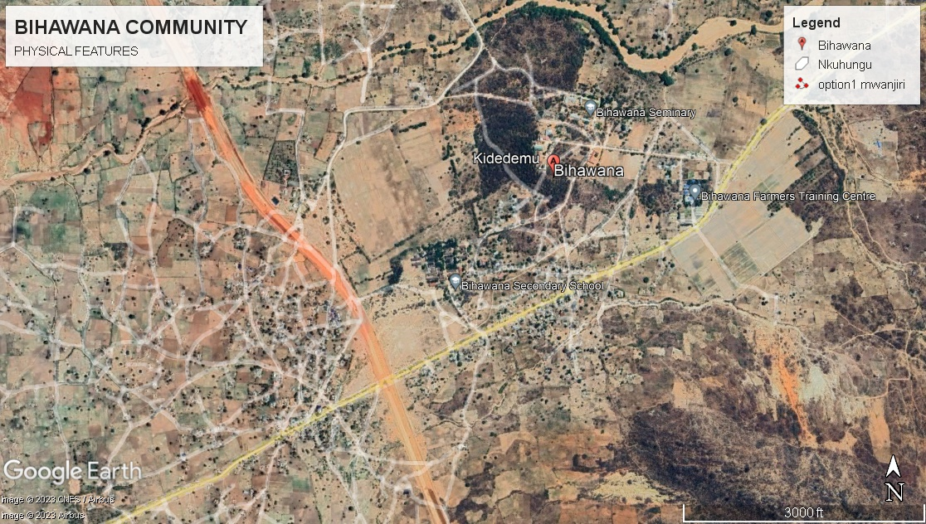

#### Figure 3: Features in Bihawana Community

## 2.2 Common Social Issues in Mapinduzi, Mpunguzi and Mbabala Mitaas

The onset of LTIP in three Mitaas will increase interaction between project workers and local community which are likely to trigger social issues such as GBV/SEA and spread of HIV/AID. Also, given the traditional practices of Gogo ethnic group who are dominant community in Mapinduzi, women are likely to be marginalized from owning land. Elders, chronically sick people, and youth such as motorcycles riders commonly known as ‘*boda-boda’* are likely not to access project benefits due to lack of project information.

The three Mitaas have no road hierarchy. Informal foot paths with size ranging between 1m to 3m are dominant in the project area and prevent access to plots and triggers conflicts. The three selected wards have basic social services such schools, health centers, religious sites, markets, and communication towers which will be identified and provided with CROs where required. In all project areas there is a need for designating land for community use such as cemetery, open spaces, and recreational parks.

# CHAPTER THREE

# LEGAL AND INSTITUTIONAL FRAMEWORK

## 3.1 Introduction

This chapter describe relevant legal and institutional framework governing this ESMP. The focus has been made on legislations as they provide environmental to social requirements relevant for the Project.

## 3.2 Country’s Legal Framework

***The Occupational Health and Safety Act, No. 5 of 2003:*** The law requires employers to provide a good working environment to workers to safeguard their health. The LTIP will ensure implementation of this act through training to drivers to eradicate incidences and accidents, provide appropriate Personal Protective Equipment (PPE) and welfare facilities such as tents, drinking water and toilet to the direct and indirect implementing teams.

***The Employment and Labor Relations Act, No. 6 of 2004:*** The Act provide labor rights and protections particularly on Child labor, forced labor and discrimination in the working place and freedom of association. The act prohibits child labor it provides that no child under the age of 14 shall be employed. LTIP will ensure equality in employment, forbid child labor and provide valid employment contracts to direct and indirect workers. The employment contracts for direct and indirect teams will ensure compliance to basic employment standards which include: i) Wage determination that stipulates a minimum term and condition of employment (ii) An employment standard constitutes a term of a contract with an employee unless -a term of the contract contains a term that is more favorable to the employee; and a provision of an agreement alters the employment standard to the extent permitted by the provisions and iii) a provision of any collective agreement, a written law regulating employment, wage determination or exemption granted under section 100. The law also requires provision for health insurance and joining to National compensation funds for labor on employment beyond six months.

***The Environmental Management Act (EMA) 2004:*** The Act provide guidance for regulation process in sensitive areas such as rivers, lakes, wetlands, forest areas, and wildlife resource among others. The Act provides a legal framework for coordinating harmonious and conflicting activities by integrating those activities into overall sustainable environmental management system by providing key technical support to Sectoral Ministries. Specifically, LTIP project in Dodoma will adhere to 60m buffer zone requirement when issuing CROs along the rivers and streams in three project sites.

***The National Land Act, No. 4 and 5 of 1999****:* The Land Act (1999 recognize that all land in Tanzania belongs to the public, and the President acts as the trustee of the land for the benefit of the people (Land Act, § 1(1)(a)). The Land Act classifies all land in Tanzania into three categories: (1) Reserved Land, (2) General Land, and (3) Village Land (§ 4(4)). The first two categories are governed under the provisions of the Land Act and its regulations. About 68% of all land is Village Land; 30% is Reserved Land and only 2% is General Land in the Country.

These Acts among other things outlines, procedure for land administration, allocation, acquisition, schemes of regularization, land registration and certification, compensation and resource management in both urban and rural areas. The Land Acts contain provisions of critical environmental importance and modalities for stakeholders’ engagement through meeting and public hearing. Both Acts translates the fundamental principles of land policy into the body of the law. One of these fundamental principles is to ensure that land is used productively and that any such use complies with the principles of sustainable development. In issuing CROs, LTIP project in Dodoma will comply to the specified provisions in land acts.

***The Urban Planning Act of 2007:*** This is the principal legislation which govern urban planning. The LTIP will prepare detailed planning schemes; undertake public and other stakeholder’s engagement; and subsequent facilitate approval of scheme of regularization as stipulated in this Act. The project will also spearhead preparation of environmental and social assessment of the proposed scheme of regularization.

***Public Health Act of 2012:*** The act among other stipulate need to consolidate public health through prevention of disease, promotion, safeguard, maintain and protect the health of humans and animals. The presence of LTIP workers may result in the risk of disease transmission will be addressed through conducting HIV/Aids campaign, provision of handwashing facilities, condoms, and dustbins.

***Water Resources Management Act No. 11 of 2009:*** Water Resource Management Act No. 11 of 2009 is the principal legislation governing the utilization and pollution control of the water resources. Specifically, the objective of this Act is to ensure that, water resources are protected, used, developed, conserved, managed, and controlled for sustainable development. The LTIP will identify streams, rivers and other water sources areas in Dodoma and will not issue CRO in such areas to enhance management of water resources.

## 3.3 World Bank Environmental and Social Framework

The ESMF has identified ESS1, ESS2, ESS3, ESS4, ESS5, ESS6, ESS7, ESS8 and ESS10 to be applicable to the LTIP. However, for Dodoma City Council the following

ESSs are applicable and this ESMP describe how specific ESSs is operationalized during issuance of CROs:

*ESS1 Assessment and Management of Environmental and Social Risks and Impacts*:

* + Screening and of environmental and social risks and impact to determine level and magnitude of risks and impacts.
  + Prepared ESMP for Dodoma for mitigating identified risk and impacts; monitoring effectiveness of proposed mitigation measures as well as enhancing project benefits.

*ESS2 Labor and Working Conditions.*

* + Provision of Valid Employment Contractors to workers for both direct and indirect teams
  + Provide PPE and welfare facilities to workers.
  + Training HIV/Aids to project workers of direct and indirect team.

*ESS4 Community Health and Safety*

* + Sensitization of community about the project and associated health risks and impacts; and
  + Training HIV/Aids to project workers of direct and indirect team.

ESS5 *Land acquisition, Restriction on Land use and Involuntary Resettlement*

* + Sensitization of community about the project and land requirements for access roads, community facilities such as schools, health facilities, markets, cemetery; reactional and open areas; and
  + Land donation requirements and procedures as stipulated in Resettlement Policy Framework (RPF);

*ESS10 Stakeholders Engagement and Information Disclosure*

* + Sensitization of community about the project
  + Formulation and operationalization of Grievance Redress Mechanism (GRM)
  + Implementation of District Stakeholders Engagement Forum (DSEF) and National Stakeholders Engagement Forum (NSEF).

# CHAPTER FOUR

# ENVIRONMENTAL AND SOCIAL IMPACTS, RISKS AND MITIGATION MEASURES

## 4.1 Introduction

Based on baseline environment and social conditions of the project area, the environmental and social assessment has identified the following likely project benefits, risks and impacts which will require attention of LTIP team:

## 4.2 Project Social Benefits

In Dodoma city the LTIP will create the following benefits:

*Security of Tenure:* Issuance of CROs will enhance security of tenure to the individual, community member and institutions such as grape farms owners and religious institutions.

*Capital Creation:* Individuals and communities will use issued CROs as collateral to access capital from financial institutions which will be reinvested in other productive activities. This also will stimulate transaction on land-based investments and raising the value of land in the three Mitaas.

*Effective Land Control and Management*: During urban certification processes different land uses will be identified and prescribed their uses. This will reduce conflicts over land and provide land for road infrastructures, social services, residential, and commercial uses. Also, the plan will identify the hazardous areas which will not be suitable for human activities and settlements.

*Reduction of Cost Associated with Informal Land Transaction:*The provision of CROs to Dodoma City community members will enhance reliability in land transaction. CROs serve as evidence of ownership of land with clear size and boundaries. Equally, it will discourage the practice of multiple sales of the same land to different buyers thus reducing conflicts over lands.

*Employments Opportunities:* Urban Certification activities in Dodoma City will require workforce to perform different activities. In total, the project will employ approximately 176 people: 32 skilled, 64 semi-skilled and 80 unskilled. Duties and responsibilities of each category of workers are detailed in CRO’s Manual.

## 4.3 Negative Social Risks and Impacts

The following are major negative social impacts associated with LTIP regularization activities in Dodoma.

1. *Conflict over land use and land rights*

In project areas people are living without proper identification of their areas, land size and boundaries with neighbors. During adjudication process the chances of not agreeing to the boundaries might lead to conflict over land. Similarly, rearrangement of access roads might require neighbors to negotiate for road access and land donation which might lead to misunderstanding among residents. In addition, some conflicts might involve resolving on who are the legal owner of the land parcels especially in the extended families, polygamous and where there are inheritance cases.

1. *Ineligibility to CROs*

Based on Annex 6 of ESMF and CRO’s Manual, communities residing within road reserve, gullies, and seasonal streams in Mapinduzi, Mkwawa and Bihawana will not be eligible for CROs as such areas are protected by Road Act of 2007 and EMA of 2004.

1. *Inequalities for Women and Other Marginalized Group*

Traditional practice of *waGogo* who dominant ethnic group in the area are, women have less access to the rights to own land. In addition, marginalized groups such as elders, long time patient, and the youth have less chances to get CROs due lack of project information. The project will require to sensitize men and other stakeholders on important of equally giving tittle deeds to women.

1. *Gender Based Violence and Sexual Harassment*

In three Mitaas, community members with access to project resources such employment, income and power over others might subject subordinates, children, spouses, and people from low-income status to GBV and Sexual Exploitation Abuse (SEA).

1. *Influx of Laborers*

Mass urban land certification will involve large number of workers from within and outside the project areas. Interactions of project workers among themselves and local community are likely to accelerate further spread of STI, crimes as well as over tasking available social services.

## 4.4 Project Positive Environmental Impacts of Land Certification

The following are positive environmental impacts of this project in Dodoma:

1. *Enhancement of protection of sensitive areas:* The project areas have gullies, river streams and road reserves which will be identified. The provision of CROs in such areas will be restricted in accordance to EMA (2004) and Road Act (2007).
2. *Livable Settlements*: The regularization process in Dodoma will create safe and conducive environment through provisions of green structures and enhancement of mobility.

## 4.5 Negative Environmental Impacts of Land Certification

The major negative environmental impacts of regularization process in Dodoma city are:

1. *Soil Erosion and Dust*

Installation of the beacons may result to localized soil erosion and dust due to the presence of loose soil around the beacons. However, these impacts are very minor.

Additionally, the fabrication of beacons activities will involve sourcing materials from quarries and borrow pits such as gravel, sand, which may result in land degradation and soil erosion and dust. However, this impact will be minor if the project will leverage on the use of iron pins to earmark plot boundaries.

1. *Waste management*

During certification process project workers will generate solid and liquid wastes such as plastic, food and human waste leading to the possibility of land and water pollution.

1. *Health and Safety Hazards*

Fabrication, transportation and subsequent installation of beacons might lead to incidences and accidents causing injuries and fatalities.

## 4.6 Mitigation Measures of the Identified Impact

This sub-section contains a description of mitigation measures for adverse impacts, measures for enhancing the beneficial effects, and the cost of mitigation against the impacts. Dodoma City Council and Ministry of Land through the LTIP Team will implement an ESMP which has been developed for LTIP project. The ESMP will also ensure compliance with applicable environmental standards during both on the land use and certification process.

**Table 1** is an Impacts and Mitigation Matrix for Land Certification for Dodoma City Council. It detailed the proposed impacts, mitigation measures, responsible party, timeframe, and costs that will be overseen and managed by LTIP project implementation team.

##### **Table 1: Mitigation Measures of Identified Impacts**

| S/N | Potential Social Impacts | Mitigation Measures | Cost Estimates (TZS) | Responsible | | Implementation Time Framework |
| --- | --- | --- | --- | --- | --- | --- |
| Implementation | Supervision |
|  | **Negative Social Impacts** | | | | | |
| 1 | Conflict over land use and land rights | * Formulation and operationalization of GRM * Capacity building and awareness creation to local leaders on conflict resolution. * To use Voluntary Land Donation Procedures in the process of negotiation for land for different land uses * Sensitization on the importance of joint land titling. * Educate men on the importance of including their wives on CROs. | 10,000,000/= | * Dodoma City E&S Team * Ward Executive Officer (WEO), * Ward Community Development Officer (CDO) * Mtaa Leaders * NGOs? | **ESMT** | During Urban Certification Process. |
| 2 | Ineligibility to CROs | * Identification of Households residing along road reserve, gullies and river streams. * Awareness on ineligibility for CROs * Payment of compensation to those along road reserve by TARURA/TANROADS as per country laws. * Liaise with NEMC and Central Water Basin Authority for further guidance. * Public awareness on the areas which have been identified as eligible for CRO | 2,000,000/= | * Dodoma City Council Urban Certification Office (CUCO) * Dodoma City E&S Team * Participatory Land Use Management Team (PLUM) * National Environmental Management Council (NEMC) * Tanzania Rural and Urban Road Agency (TARURA) * Tanzania Road Agency (TANROADS) & * Central Water Basin Authorities. | **ESMT** | During identification of Parcels. |
| 3 | Inequalities for Women and Other Marginalized Group | * Identification of marginalized groups such as women, elders, chronically ill persons and youth * Sensitization on importance of CROs and other project benefits. | 2,000,000/ | * Dodoma City E&S Team * Ward Executive Officer (WEO), * Ward Community Development Officer (CDO) * Mtaa Leaders * Civil Society Organisation (CSOs). | **ESMT** | During Project Sensitization and identification |
| 4 | Gender Based Violence | * Engage Police Gender Desk to train Project staff on GBV/SEA. * All LTIP staff to sign a code of conduct (CoC) which include GBV/SEA issues. * To develop a GBV Action Plan for the District. * To identify relevant government agencies and/ or NGOs in the district who can provide survivors of GBV and SEA assistance for example medical care, psychosocial support, legal redress, safety, etc. as and when necessary. | 8,000,000/= | * Dodoma City E&S Team * Ward Executive Officer (WEO), * Ward Community Development Officer (CDO) * Mtaa Leaders * Private Companies involved in certification activities. | ESMT | Before placement of employees and During Urban Certification Process. |
| 5 | Influx of Laborers | * Community awareness on STIs transmission and basic hygiene practice and crimes * Give priority to unskilled laborers from within project areas. * Provision of welfare facilities such as water, toilets and food vending to project workers. | 2,000,000/= | * Dodoma City Council Urban Certification Office (CUCO) * Dodoma City E&S Team * Mtaa Leaders * Private Companies involved in certification activities. | **ESMT** | During Urban Certification Process. |
| Negative Environmental Impacts | | | | | | |
| 1 | Soil Erosion and Dust | * Tree and grass planting * Dust suppression using water * Provision of PPEs (Mask, Boots, Gloves and Helmet) to workers. | **500,000/=** | * Dodoma City Council Urban Certification Office (CUCO) * Dodoma City E&S Team * Private Companies involved in certification activities. * Mtaa Leaders | **ESMT** | During Urban Certification Process. |
| 2 | Waste management | * Provision of dustbins in all project areas * Use of welfare facilities such as toilets and water. | **800,000/=** | * Dodoma City Council Urban Certification Office (CUCO) * Dodoma City E&S Team * Private Companies involved in certification activities. * Mtaa Leader | **ESMT** | During Urban Certification Process. |
| 3. | Health and Safety Hazards | * Provision of PPEs (Mask, Boots, Gloves and Helmet) to workers. * Training drivers of direct and indirect teams on road safety * Provide Health and safety Training to project workers | **2,000,000/=** | * Dodoma City Council Urban Certification Office (CUCO) * Dodoma City E&S Team * Private Companies involved in certification activities. * Mtaa Leaders | **ESMT** | During Urban Certification Process. |

# CHAPTER FIVE

# ENVIRONMENTAL AND SOCIAL MONITORING PLAN

## 5.1 Introduction

This ESMP establishes benchmarks which will be used to assess the level of compliance with this ESMP. Monitoring will be continuously and will be periodically reviewed to determine effectiveness of implementation different mitigation measures. Therefore, monitoring plan specifies the institution arrangement for execution of ESMP. In particular, it clarifies type of monitoring; who will carry out monitoring and what other inputs such as training are necessary.

The objectives of Environmental and Social monitoring plan are:

* To monitor the effectiveness and implementation of ESMP during planning and CROs issuance phases of proposed mitigation measures;
* To confirm compliance with environmental, social and safety legislation/regulations during certification as well as safeguards tools and instrument in pace;
* To control the risks and ecological/social impacts;
* To ensure best practices management as a commitment for continuous improvement in environmental and social performance;
* To provide environmental information to community/stakeholders;
* To provide early warning signals on potential environmental degradation for appropriate actions to be taken so as to prevent or minimize environmental consequences;

The **Table 2** below summarizes monitoring plan for urban certification in Dodoma City Council:

##### **Table 2: Environmental and Social Monitoring Plan for Implementation of Mitigation Measures during Land Certification and Registration Process in Dodoma City Council**

| **S/N** | **Environmental/ Social Impacts** | **Monitoring Parameters** | **Targets/Legal Standards** | **Monitoring Methods** | **Frequency /Duration** | **Responsibility**  **Host institution**  **Supervising institutions** | **Monitoring Budget** |
| --- | --- | --- | --- | --- | --- | --- | --- |
| **Enhancement of Social Benefits** | | | | | | | |
|  | Security of Tenure | No. of CROs issued in each Mtaa | 30,000 | ILMIS data | Quarterly | ESMT & PIT | **1,000,000/=** |
|  | Capital Creation | No. of Beneficiaries using CROs to secure capital. | 20 | Project report | Quarterly | ESMT & PIT | **1,000,000/=** |
|  | Effective Land Control and Management. | Percentage decrease of land related conflict cases in three Mitaas. | 50% | Project Report | Quarterly | ESMT & PIT | **1,000,000/=** |
|  | Reduction of Cost Associated with Informal Land Transaction | Percentage decrease of cost associated with access to land to three Mitaas. | 100% | Project Report | Annually | ESMT & PIT | **1,000,000/=** |
|  | Employments Opportunities | No. of people employed | 174 | Report | Quarterly | ESMT & PIT | **0** |
| **Enhancement of Environmental Benefits** | | | | | | | |
|  | Enhancement of protection of sensitive areas | Number of land development within sensitive areas (Gullies & river stream). | 0 | Report | Quarterly | ESMT & PIT | **1,000,000/=** |
|  | Livable Settlements | Percentage of green structures and enhanced mobility in three Mitaas | -10% green structures &  -15% mobility | Scheme of regularization | Annually | ESMT & PIT | **1,000,000/=** |
| **Social Negative Impacts** | | | | | | | |
|  | Conflict over land use and land rights | Percentage decrease of land related conflict cases in three Mitaas. | 50% | Report | Annually | ESMT & PIT | **1,000,000** |
|  | Number of resolved land conflicts | No of land conlicts resolved | 100 Conflicts | Report | Quarterly | ESMT & PIT | **1,000,000/=** |
|  | Ineligibility to CROs | No of identified ineligible parcels in three Mitaas | N/A | Report | Quarterly | ESMT & PIT | **1,000,000/=** |
|  | Inequalities for Women and Other Marginalized Group | Percentage of Women and other Marginalized Group with CROs. | 30% | Report | Quarterly | ESMT & PIT | **1,000,000/=** |
|  | Time spent for Resolving Gender Base Violence | Time | ~~0 Five Days~~ | Report | Quarterly | ESMT & PIT | **1,000,000/=** |
|  | Influx of Laborers | Percentage of laborers employed from within the project areas. | 40% | Report | Quarterly | ESMT & PIT | **1,000,000/=** |
| **Environmental Negative Impacts** | | | | | | | |
|  | Soil Erosion and Dust | No. of trees planted | 150 trees @ 50 mtaa | Report | Quarterly | ESMT & PIT | **1,000,000/=** |
|  | Waste Management | No. of dustbins provided in three Mitaas | 15 dustbins @ 5 Mtaa | Report and observation | Quarterly | ESMT & PIT | **1,000,000/=** |
|  | Health and Safety Hazards | No. of incidence and accidents reported. | 0 | **Report** | Quarterly | ESMT & PIT | **1,000,000/=** |
|  | Early Warnings Signals | No of warnings Issued | 2 Warnings | **Reports** | Quarterly | LGA, ESMT | **1,000,000/=** |

# CHAPTER SIX

# INSTITUTIONAL ARRANGEMENTS FOR IMPLEMENTATION OF ESMP IN DODOMA CITY

## 6.1 Introduction

## The implementation of ESMP will follow the plan stipulated in ESMP. For Dodoma City Council the following will be involved in the implementation of this ESMP.

## 6.2 ESMP Implementing Institutions

*Dodoma City Council Urban Certification Office (CUCO):* This will be responsible for daily certification activities which will involve support to Dodoma City E&S Team

*Dodoma City E&S Team:* This will be responsible for implementation of the E&S activities including the proposed mitigation and enhancement measures with the support from CUCO.

Participatory Land Use Management Team (PLUM): This will be responsible for identification of households residing along road reserve, gullies and river streams.

*National Environmental Management Council (NEMC) and Central Water Basin Authorities:* Will provide further guidance on households residing along, gullies and river streams.

Tanzania Rural and Urban Road Agency (TARURA) and Tanzania Road Agency (TANROADS): Will provide further guidance on households residing along the roads including payment of compensation where applicable.

*Ward and mtaa Leaders:*These will be involved in conflict resolutions through operationalization of project GRM, identification of marginalized groups such as women, elders, chronically ill persons and youth, and sensitization on importance of CROs, waste management, GBV/SEA matters, health and safety and other project related benefits.

*Civil Society Organization (CSOs)*: They will be responsible for ensuring all this project. Sensitization on importance of CROs and other project benefits, importance of joint titling and GBV/SEA matters.

*Private Firms:* Private firms will be responsible for provision of PPEs (mask, boots, gloves and helmet) to workers; training drivers of direct and indirect teams on road safety; provide health and safety training to project workers; provision of dustbins in all project areas; provision of welfare facilities such as toilets and water; tree and grass planting; dust suppression

## 6.3 Supervision and Monitoring Roles

*Project Environment and Social Management Team (ESMT):* shall be responsible for ensuring compliance with ESMPs. In particular, the team will conduct regular audits and prepare the reports that demonstrate implementation of the ESMP . The team will be required to submit monthly reports to MLHHSD. The MLHHSD through PCU then will be required to submit quarterly reports on ESMP implementation to the World Bank.

## 6.4 Capacity Development and Training

Capacity development training for LTIP is stipulated in ESMF. For Dodoma city council the following trainings have been provide to E&S Team at LGAs levels and Mitaas leaders to enhance their capacity to implementation of environmental and social risk management issues during certification process (Table 3).

##### **Table 3: Training Activities**

|  |  |  |  |
| --- | --- | --- | --- |
| **S/N** | **Name of Training** | **Training Institution** | **Date** |
|  | Environmental and Social Framework Training to LGAs E&S Teams | World Bank | 13th – 14th December 2022 |
|  | Preparation and Implementation of ESMP to CUCOs members. | ESMT | 21st - 23rd December 2022 |
|  | Training on Safeguards Compliance to Mitaas and ward Leaders | ESMT | 3rd – 4th March 2023 |

Other E&S trainings planned for Dodoma City to enhance their capacity to implement ESMP are:

1. Health and safety Training to project drivers and field teams to be conducted in May 2024.
2. Training on implementation of ESMP to private firms to be conducted prior to certification process;
3. Training of code of conducts for GBV/SEA and ethics practice to ESMT and Dodoma City Council E&S Team to be conducted on June 2024;

# CHAPTER SEVEN

# CONCLUSIONS AND RECOMMENDATIONS

## 7.1 Conclusions

This ESMP is specifically for Dodoma City Council LTIP activities. It proposes mitigation measures to minimize the adverse impacts, while enhancing the positive ones. The assessment and evaluation process of the proposed project activities indicates that the project will bring net social benefits within the project area. Negative implications of this project have been identified, and need to be mitigated, in order to make this project environmental and socially sound.

The social benefits of this project to include enhanced security of tenure, capital creation, effective land control and management, reduction of cost associated with informal land transaction, and employments opportunities.

Apart from the positive impacts, this ESMP also identified some negative implications associated with the proposed interventions, which need to be mitigated in order to ensure project acceptability and sustainability. Among the negative impacts are: Conflict over land use and land rights, ineligibility for some people to obtain CROs, inequalities for women and other marginalized group, likely of emergence of gender-based violation, influx of laborers, soil erosion and dust, generation of waste, and health and safety hazards.

To address the aforementioned risks and impacts, the ESMP include a comprehensive Environmental and Social Management Plan (ESMP) and a Monitoring Plan for proper implementation of the project and reduction of the negative effects from the project. The MLHHD is committed to effect this ESMP through ensuring that enough budget, human resources and logistics are available.

## 7.2 Recommendations

* All mitaa / wards where the project is implemented should have the copy of this ESMP,
* Private firms to be hired to conduct certification process in Dodoma should be given this ESMP as part of the contract to ensure its implementation,
* Adequate budget should be allocated to facilitate implementation of the mitigation measures to avoid project impacts to the environment and the community and enhance project benefits.
* Training to all stakeholder on E&S issues is key for achieving the objectives of this ESMP. All key stakeholders identified in this ESMP must be trained to facilitate smooth implementation of the E&S issues during project implementation.